What is a Piecewise Function?
How to Evaluate a Piecewise function
How to Graph a Piecewise Function
How to Write a Piecewise Function

A piecewise function is a functions defined by __________  _____________ more ____________________. Each “piece” of the function applies to a different part of its  _______________ (____ value). | Example  f(x)= $x-2, if x≤0$  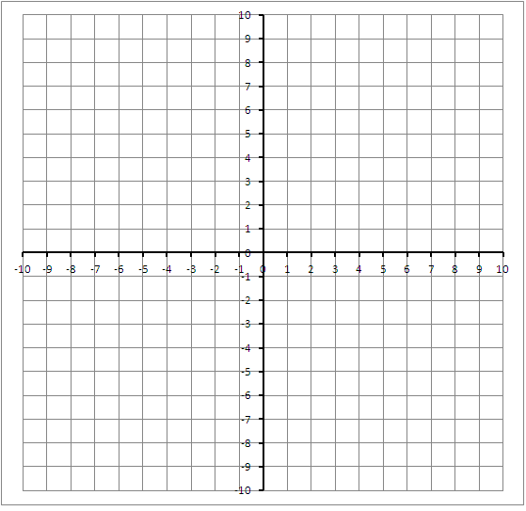  $2x+1, if x>0$
To _______________ a piecewise function, _____________  the value of ___into the rule for the part of the  _____________ that includes the value of x. | Evaluate the function f when (a) x=0 and (b) x=4  f(x)= $x-2, if x≤0$  $2x+1, if x>0$  a: ____________  b: ____________
To ________________ a piecewise function, do above steps  for evaluating a function, using multiple values for  _____. Graph each piece ______________________. | f(x)= $x-2, if x≤0$  $2x+1, if x>0$
To ________________ a piecewise function, write a  ______________________ for each piece. | Left Piece: When x ____0,  Right Piece: When x ____0,

