Name: ____________________
3rd Quarter Review
Algebra 1A
Determine whether the relation is a function. If the relation is a function, determine whether the function is linear or nonlinear. (2 points each)

1.
x | 2 | 5 | 7 | 9 | 14
y | 5 | 11 | 19 | 12 | 3

_____________________ ___________________________
2.$y=-6x+8$

_____________________ ___________________________

Identify the independent and dependent variables. Sketch a graph.(4 points each)

3. The movie theater in Florence sells more tubs of popcorn when they are showing more comedies.

__________________________ depends on ___________________________

4. Jesse runs faster when a bear is closer behind him chasing him.

__________________________ depends on ______________________________

Determine if the function is discrete or continuous. (1 point each)
5.
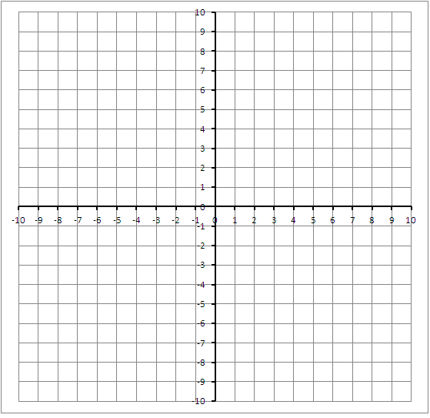 ___________________________________

6. The number of cookies baked depends on the number of bags of chocolate chips Jozzy has in her cupboard.

Determine the domain and range. (2 points each)
7.

Domain: __________________-
Range: ___________________

8.
x | y
2 | 2
7 | -1
12 | -4
17 | -7

Domain _________________

Range __________________

Fill in the blanks for each function. (5 points each)
9. $f\left(x\right)=4x-2$

Name of the function: ____________

The actual function: ____________

Evaluate for -3:__________________

Write as an ordered pair: ____________

10. $g\left(x\right)=-2x+6$

Name of the function: ____________

The actual function: ____________

Evaluate for -3:__________________

Write as an ordered pair: ____________

Solve the equation. (2 points)
11. $-2x=3x+10$

