Name: ____________________
3rd Quarter Review
Algebra 1B
Determine whether the relation is a function. If the relation is a function, determine whether the function is linear or nonlinear. (2 points each)

1.
x | 2 | 5 | 7 | 9
y | 5 | 11 | 19 | 12

_____________________ ___________________________
2.$x=-2$

_____________________ ___________________________

Graph the equation and identify the intercepts. Find the slope. (5 points)
3. $y=5$
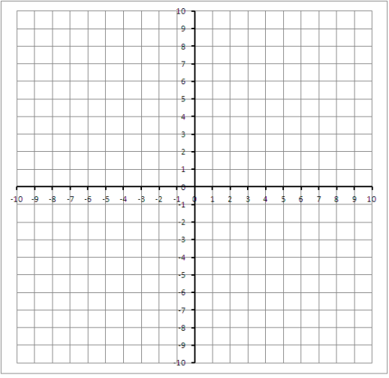

x-intercept: __________________

y-intercept: __________________

slope: _______________________

Evaluate. (3 points)
4. $g\left(x\right)=4-3x$ when x = -3, 0, and 5.

Find the value of x so that the function has the given value. (1 point)
5. $r\left(x\right)=-5x-1;r\left(x\right)=19$

Graph the Linear Equations. (2 points each)
6. $-12x-3y=36$
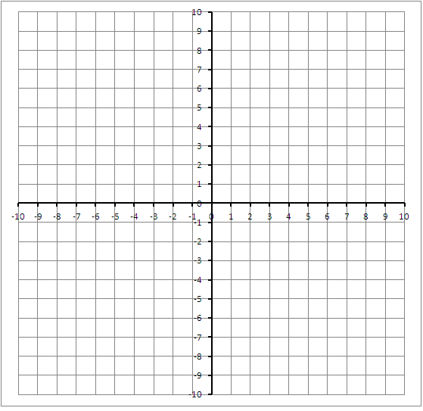

7. $x=6$

Graph the function. Compare the graph to the graph of $f\left(x\right)=$|x|. Describe the Domain and Range. (5 points each)
8. $q\left(x\right)=4|x|$

9. $r\left(x\right)=-\frac{1}{4}|x|$

Solve the inequality. Graph (number line) if possible. (3 points)
10. $-4s<6s+1$

