Name: ______________________
Algebra 1B 2nd Quarter Review
You may use your Interactive Notebook (INB) for any of these problems and those on the test. You will also be allowed to use your review on the test.
Inequalities
Write the sentence as an inequality. (1 point each)
1. A number n plus 7 is less than or equal to 9.

Graph the Inequalities (1 point)
$$2. s<|1|$$

Solve and graph the Inequality (1 point for showing your work, 1 point for the correct answer, 1 point for the correct graph)
$$3. 9+w>7$$

Solve and graph the Inequality (2 points for showing your work, 1 point for the correct answer, 1 point for the correct graph).
$$4. 5x-12≤3x-4$$

Parts of a Coordinate Plane
Label the following on the coordinate plane : (1 point each)
- X-axis
- Y-axis
- All quadrants
- 14.(4, 2)
- 15.(-3, 5)
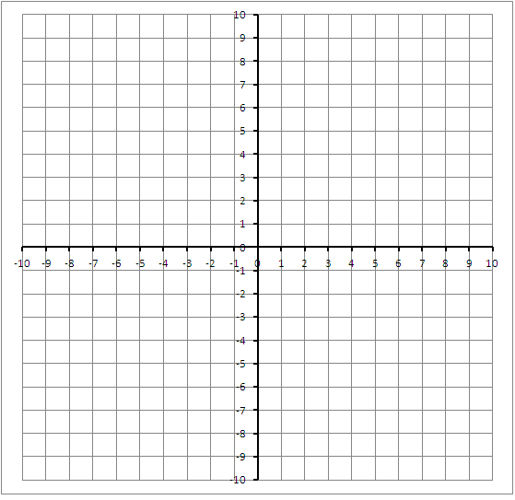

Functions:
Is this a Functions? Label yes or no. (1 point)
- ____________ Input Output
2
3
4
0
1
2

Graph the linear equations. (3 points each)
$$11. p\left(x\right)=4x$$
$$12. f\left(x\right)=3-6x$$

Slope
Identify the slope as positive, negative, zero, or undefined from each graph. (1 point each)
13 . _________________________
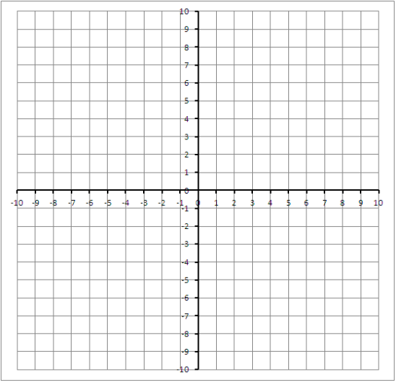
14. __________________________
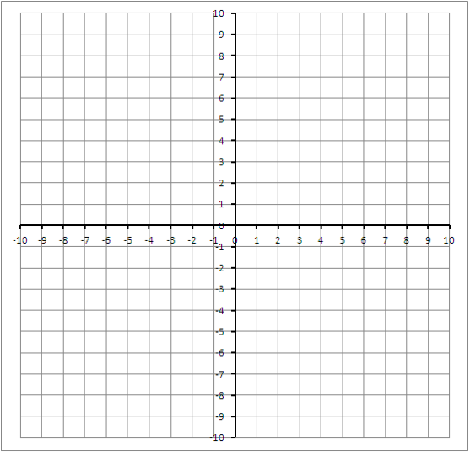

Calculate the rise and run to find the slope of each line. Find both intercepts. Write the equation. (5 points each.)
15.
Slope: ________
X int: ________
Y int: ________
Equation: ________________________

16.
Slope: ________
X int: ________
Y int: ________
Equation: ________________________

