How to Pop Corn on the Cob

- Pull the husks off of your corn cobs
- Microwave the corn cobs one at a time. Stick one in a plain brown paper lunch bag and fold over the top a few times. This cob was huge, so I doubled up lunch bags and microwaved it that way.

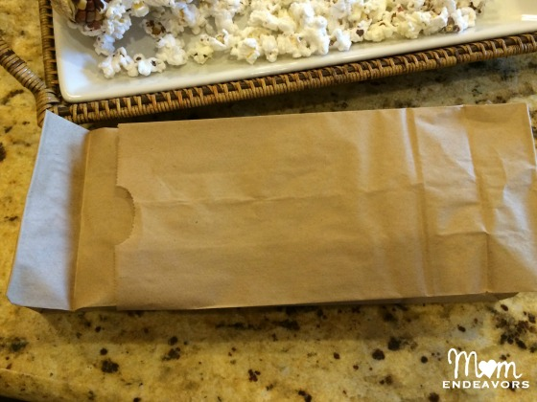
- I use the “popcorn” button on my microwave–it runs about 4 minutes. You can’t walk away from the microwave while these are cooking because they’re pretty temperamental. They’ll sit for 2-3 minutes without any popping, then they’ll all pop in about 30 seconds. Start the microwave and wait for popping sounds. Once they slow down to 1-2 every few seconds, stop the microwave.
- Carefully pull the bag out of the microwave. The corn cob will be very hot, so be careful and keep little hands away!

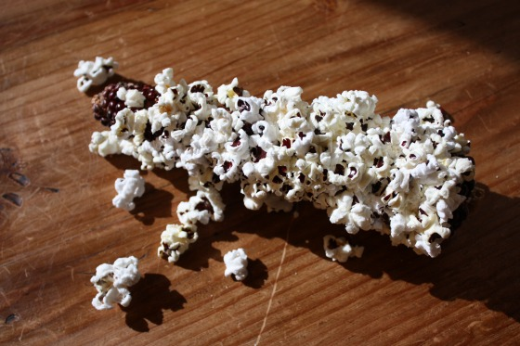
- Keep popping your corn cobs and pouring the popcorn into a bowl or onto a tray. Add melted butter and salt if you’d like!

