Rolling dice for point-slope form

This year I did something wrong. Something seriously wrong.
What did I do wrong? I'm not entirely sure. But, my students are convinced that point-slope form is easier than slope intercept form. This. Has. Never. Happened. Before. My students normally dread point-slope form. They cry. They whine. They threaten to drop out of school because algebra is too hard. The week or so that we spend actively engaged in working with point-slope form is not a happy week. At least it wasn't until this year.
So, what was different? I can think of two things.
Giant Foam Dice and Desmos.
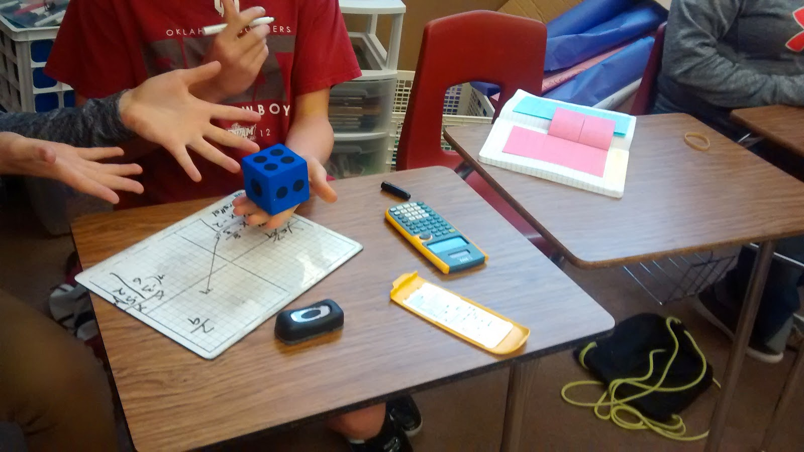
Instead of giving my students problems, I let them create their own problems. Or, I guess I should say the dice created their problems for them. First, students worked together in pairs of two. Each pair got a giant foam die. My math teacher coworker across the hall gave me these right before school started. They are SO handy!
ecide before you start how to determine which numbers will be positive and which will be negative. We decided to make odd numbers negative and even numbers positive. This worked okay. It led to a lot more horizontal and vertical lines than if you flipped a coin to determine positive/negative. But, I think I'm okay with that. Usually, I neglect to give my students enough practice with problems where the points form a line with zero or undefined (or Undefiiiiiiiiiinnnnneeeeddd! as Slope Dude would say) slope.
Roll the die twice to form the first ordered pair. Roll the die two more times to form the second ordered pair. At this point, students knew from their notes on point-slope form that they had to determine the slope of the line that went through these two points. However, my students knew they had two options. They could graph the two points and find the slope that way. Or, they could use a table and their vertical number lines to find the slope. (More about that here!) Students could pick whichever way they felt more comfortable.

It was so good to see kids using their notebooks. It's a reminder that the notes we take in class really do make a difference.
Having found the slope, students plugged the slope and one of their points into the formula for point-slope form. Then, we converted the equation to slope intercept form for even more practice with slope-intercept form.
This is where things take a radical turn from how I've done them in the past. Usually, I would be like "Yay, we found the equation of the line. Go us! Let's do another one." The problem with this is that my students aren't convinced that this equation actually goes through these points. Assuming we've made no errors, I'm convinced. But, then again, I'm an algebra teacher. The thought of teaching equations is what makes me want to get out of bed in the morning. My students? Not so much.

My students need to be convinced, though. I could have them graph the two points and graph the line they found in slope intercept form. But, knowing my students, they would probably just draw a line through the two points and "pretend" it matched the equation. No, they need better proof. Definitive proof. And, that's what desmos provided us.
If my school had laptops, or ipads, or wifi access for students, I would let them each check their own work as they went. But, sadly, that's not the type of school I work in. We don't even have a computer lab that we can take students to. I see the activities that other teachers are able to do with their students and desmos, and I get super jealous. Extremely jealous. Life goes on, though. And, I remind myself that I am providing the best education for my students that I know how to with the resources I have been provided with.
Anyway. Let's get back to how I was able to use desmos in my classroom. I pulled up desmos on my desktop computer. As pairs of students found the equations that went through their pairs of points, I had them bring their dry erase boards up to my desk. I inserted the two points they had rolled with the dice into desmos. Then, with great fanfare, I typed in the equation they had come up with.

One of two things happened. Cheers because the line very clearly went through both points. Or groans. The students who cheered were sent back to their desks to repeat the process with newly rolled points. The students who groaned were sent back to their desks to look for their mistake.
The feedback was instant and glorious. Thank you Desmos!

And, there's just something different about the computer screen telling you you're right and your math teacher telling you you're right.

