Solving Equations by Graphing
- You can use _________________
_______ to solve an equation with ___________ on both sides.
$$-x+1=2x-5$$
Graphically:
Make each side of the ____________ equal to ____.

__=___________

__=___________
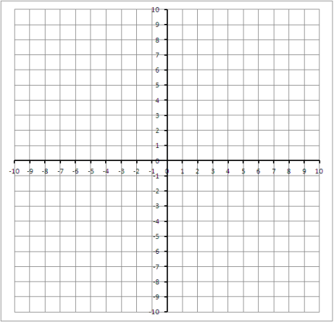
Solution: ____
X= ______
Algebraically:
$$-x+1=2x-5$$
Solving Absolute Value by Graphing
$$\left|x+1\right|=|2x-4|$$
______ related equations
_____________ AND ____________

Solution: _______ Solution: _______
X= ______ X= ______

