Special Systems of Linear Equations
Numbers of Solutions of Linear Equations
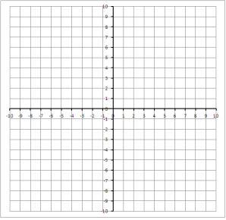
_________ Solution
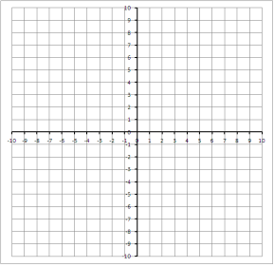
________ Solution
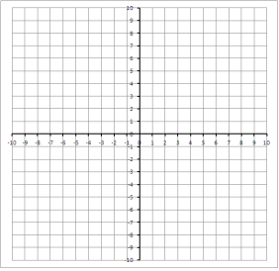
____________ __________ Solutions
No Solution
$y=2x+1$ $y=2x-5$

Graphing:
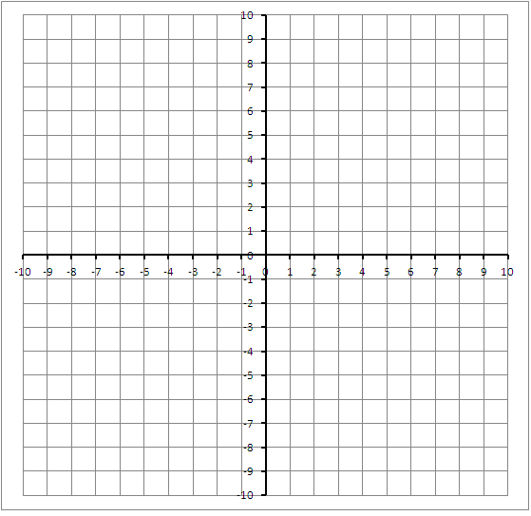
Substitution:

Same _________, Different ____________=no solution
Infinitely Many Solutions
$-2x+y=3$ $-4x+2y=6$

Graphing:
__________ slope AND __________ y intercept, so __________ line.
__________________ _________________ solutions

